8:06 PM BC: meeting started

1. Intro
   1. Planned four meetings, in person
   2. Startup Potential in the US
   3. CHECK BY THE LAB, PLAN THAT
2. Project Beginnings
   1. Project problem statement
      1. The problem we are trying to solve is to avoid the loss of assets and time when samples thaw
   2. Potential solution

i. A potential solution is a digital lock that connects to the door that connects to an app

* 1. Found only one company that sells this but they are selling this at ~$900 and in China
     1. Expensive
  2. Client has searched for lock on amazon
     1. Looked for ways to record opening and closing doors
  3. Deliverable: Either software or hardware
  4. “Self made digital lock app tutorial”
     1. How to make a smartphone connect door lock by hacker shack ([How to Make a Smartphone Connected Door Lock](https://www.youtube.com/watch?v=bAcK80fm1_0))
     2. Arduino/Raspberry Pi may be helpful
  5. **Sifeley**, interface close to what the client want
     1. Bluetooth, not wifi
        1. We want wifi
     2. Remote compatibility (results can be seen from a distance, also avoids the problem of not connecting to bluetooth properly)
     3. (Potentially use Imagica to help with app design ideas [Imagica A new way to think and create with computers | Build a no-code AI app in minutes](https://create.imagica.ai/fot/#/editor))
     4. Car lock app link at [How to make IoT Door Lock | Blynk App Tutorial | Internet of Things | IoT projects using Arduino](https://www.youtube.com/watch?v=VP0qLUOdvuU)
  6. Security ideas

i. Ability to secure stronger

1. Lab Tour
   1. Lab specifically has many refrigerators(6)
      1. Expensive reagents
      2. Tubes expensive, 9x9 300$ each tube
         1. Possible loss of $200k/year
      3. We’ll need to make something that can be produced easily
      4. Twice last year someone forgot to close the door, everything melted and $100000 was lost.
   2. Do we want it to make sure that it knows if the door is open for too long?
2. Q&A
   1. 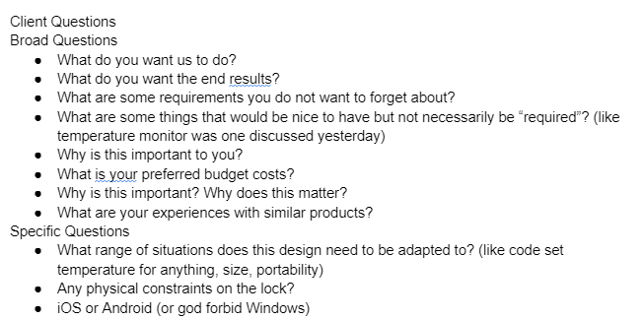
   2. 4 , -20, and -80 degree refrigerators
   3. Inventory sensor or internal camera would be nice but not required
   4. Adaptability for future features
      1. Also for various other compartments that may need locks
   5. Mainly about how big the market is
      1. Product for the professionals first, then eventually for the public
   6. Doesn’t need to be *terribly* secure, though obviously would be nice the more secure it is
      1. Idea; we could use that string lock to help make sure to close doors
   7. Problem with current solution (expensive and problems with door height with potentially being too high, though our project should not have this problem)
      1. I’m guessing that it’s due to magnetism and how it needs to be close to close
   8. This needs to be user friendly and should not be drilled in

i. Do adhesives research

3M tape would be a good starting point

i. Make this design durable (should be fine with room temperature)

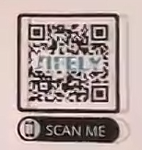

<https://www.sifely.com/blue>

Address: 3101 Clinical Lab Building (Research II) UC Davis Medical Center, 4625 2nd Ave., Sacramento, CA 95817

Phone Number: 916-591-6684

BC 9:00 PM